**COURSE-4**

**PYTHON FOR DATA SCIENCE, AI & DEVELOPMENT**

**Course Layout**

**Module 1:** Python Basics

* About the Course
* Types
* Expressions and Variables
* String Operations

**Module 2:** Python Data Structures

* Lists and Tuples
* Dictionaries
* Sets

**Module 3:** Python Programming Fundamentals

* Conditions and Branching
* Loops
* Functions
* Exception Handling
* Objects and Classes
* Practice with Python Programming Fundamentals

**Module 4:** Working with Data in Python

* Reading and Writing Files with Open
* Pandas
* Numpy in Python

**Module 5:** APIs and Data Collection

* Simple APIs
* REST APIs, Web Scraping, and Working with Files

This course was designed to provide the building blocks for Python programming and data collection for those choosing a career in Data Science, Data Engineering, AI, or Application Development.

Initially conceived as a foundation course for Data Science and AI it has been refreshed several times to keep pace with emerging career options. Additional content has been added which is applicable to Data Science, Data Engineering, AI, or Application Development.

After completing this course, you will have learned foundational skills in Python programming which you can then go on to apply in the Python Project course for your chosen career.  The Python Project courses involve real world scenarios where you oversee a final project as a Data Scientist, a Data Engineer, or in AI and Application Development. By finishing this course and your follow-on Python Project, you will gain the basic skills to continue the steps on your chosen career path.

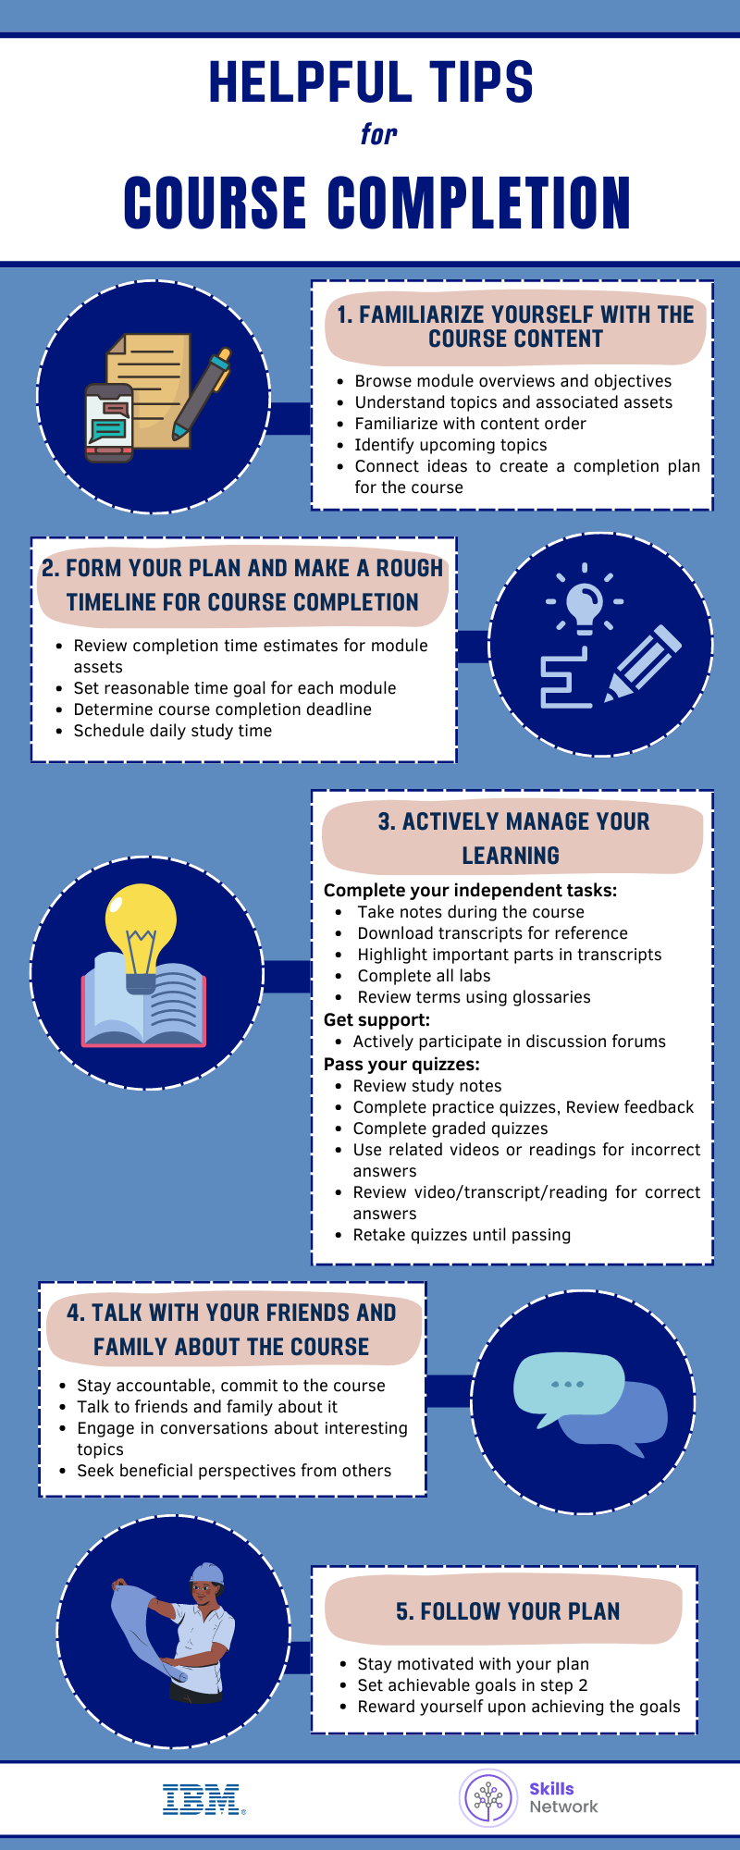

**Module-1**

**Module-2**

**Module-3**

**Module-4**

**Module-5**